B – Unit and Lesson Planning d (484 words)
d. (i) Definition of Instructional Scaffolding
‘Scaffolding in education was a term coined by Jerome Bruner, a psychologist in the 1960. It is closely tied to the theory of the Zone of Proximal Development which was developed by the psychologist Lev Vygosty, which refers to the difference between what learners can accomplish independently and what they can achieve with guidance from a more knowledgeable individual. It suggests that there is an optimal window of learning where students can accomplish a task which they couldn’t achieve on their own with the help of a knowledgeable guide. Effective scaffolding occurs within this optimal learning window which involves guiding the student to reach their full potential.’ Drew (2024)
Instructional scaffolding is a teaching approach in which the teacher provides temporary support to learners as they develop new knowledge and skills. These supports enable students to complete tasks that they may not be able to accomplish independently. As learners become more confident and competent, the teacher gradually reduces the assistance provided, allowing students to assume greater responsibility for their learning.
d. (ii) Contingent Instructional Scaffolding is a dynamic teaching approach where an instructor adjusts the amount and type of support in real time based on how a student responds during a lesson. (Client Challenge, n.d.)
Contingent scaffolding has four component parts that function as a cyclical loop:
1. Diagnostic Assessment (Diagnostic Strategies)
The process begins with the teacher actively gathering data on the learner’s current understanding or progress barriers. This involves observing student actions, mistakes, asking specific questions, identifying gaps and specific misconceptions.
2. Adaptation / Determination of Contingent Support
Once the teacher determines the student's exact point of need, an appropriate strategy is designed which is neither too simple or too advance. This indicates whether visual prompts, tools, conceptual help is needed.
3. Intervention (Scaffolding Execution)
The teacher applies the chosen scaffolding strategy to bridge the gap. Interactive strategies include Chunking Cues: breaking down a complex problem into micro-steps; and Prompting and Cueing: hints or clues that prompt the student into solutions rather than giving the answer.
4. Checking Student Response (Evaluation & Fading)
Evaluating student’s responses dictates the next step. If progress is shown, the teacher systematically reduces or removes the support, thus handing the cognitive control back to the learner [Fading]. If the student still struggles, the cycle needs to be repeated with more or different support.

d. (iii)
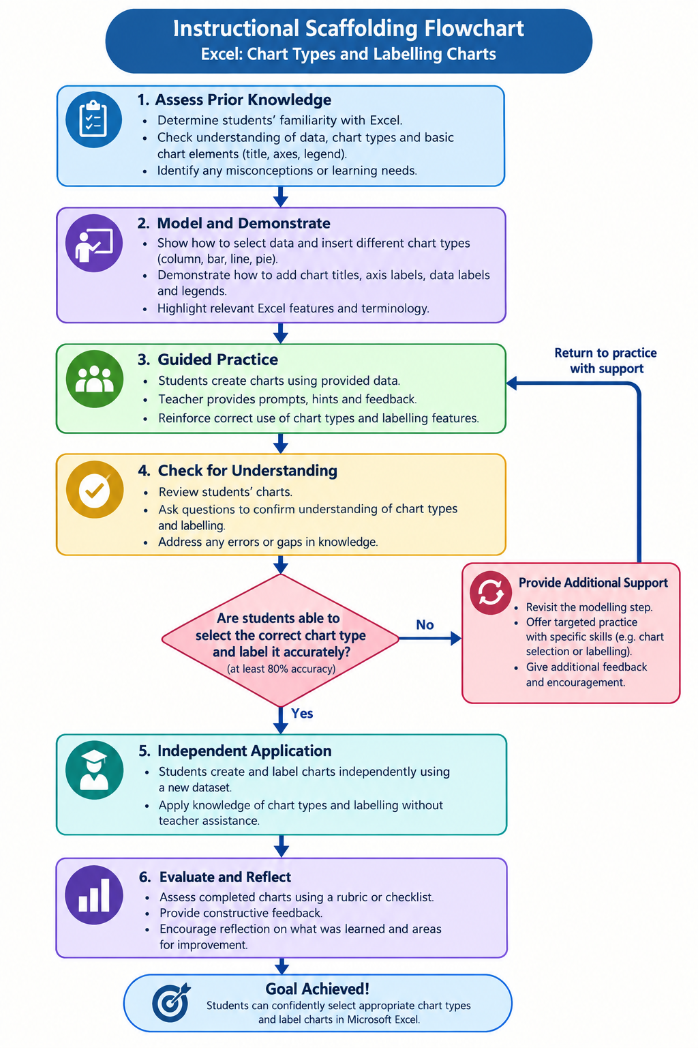

d. (iv) Flow Chart Explanation
The flowchart above illustrates an instructional scaffolding process for teaching Excel chart types and labelling to a form four class. It begins by assessing students’ previous knowledge, followed by teacher demonstrations and guided practice. After which, the students’ understanding is evaluated to determine whether they can select and label charts accurately. Students needing additional support will receive targeted instructions and practice, while successful students proceed to work independently. Finally, their work is assessed, feedback is provided, and reflection is encouraged. The process aims to develop students’ confidence and competence in creating and labelling charts in Excel.
References
Client challenge. (n.d.). https://www.edresearch.edu.au/guides-resources/practice-guides/scaffold-practice
Drew, C. (2024, May 3). Instructional Scaffolding in Education (Examples & Techniques). Helpful Professor. https://helpfulprofessor.com/instructional-scaffolding-strategies/
San Martin, M. G. (2018). Scaffolding the learning-to-teach process: A study in an EFL teacher education programme in Argentina. Profile: Issues in Teachers´ Professional Development, 20(1), 121–134. https://doi.org/10.15446/profile.v20n1.63032

